How to access Classification descriptions

Classification (job) descriptions are viewable in EIS. Please contact hrcomp@untsystem.edu to request updates to classification descriptions.
To access the classification descriptions, navigate to Employee Self Service and click on the tile labeled Classification Description.
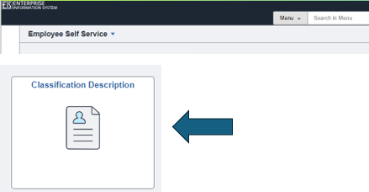

Basic Search
The basic search page is shown below. To broaden a search, click “Advanced Search” if needed. In basic search, you can search for a job description by entering the job title or the beginning of the job title into the “Profile Name” field. If you are unsure of the title, use the % symbol as a wildcard to broaden the search results. For example, %Admin will result in all titles containing Admin.
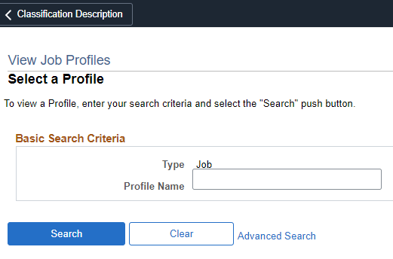
Advanced Search
Advanced Search provides the ability to search by job code in the Profile ID field. Note: all job codes are preceded by the entity name (DAL, HSC, SYS or UNT).
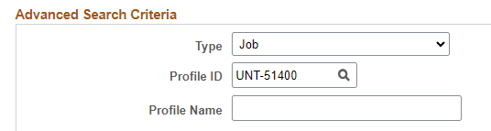
After clicking on the desired job profile name in the search results, you can review the job description content or to print the job description, click the Print icon.
